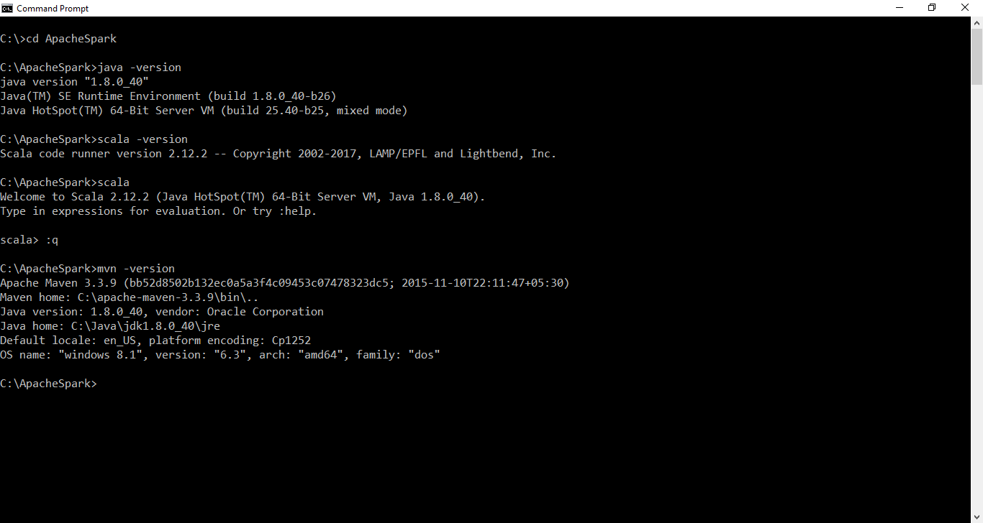

Run as administrator

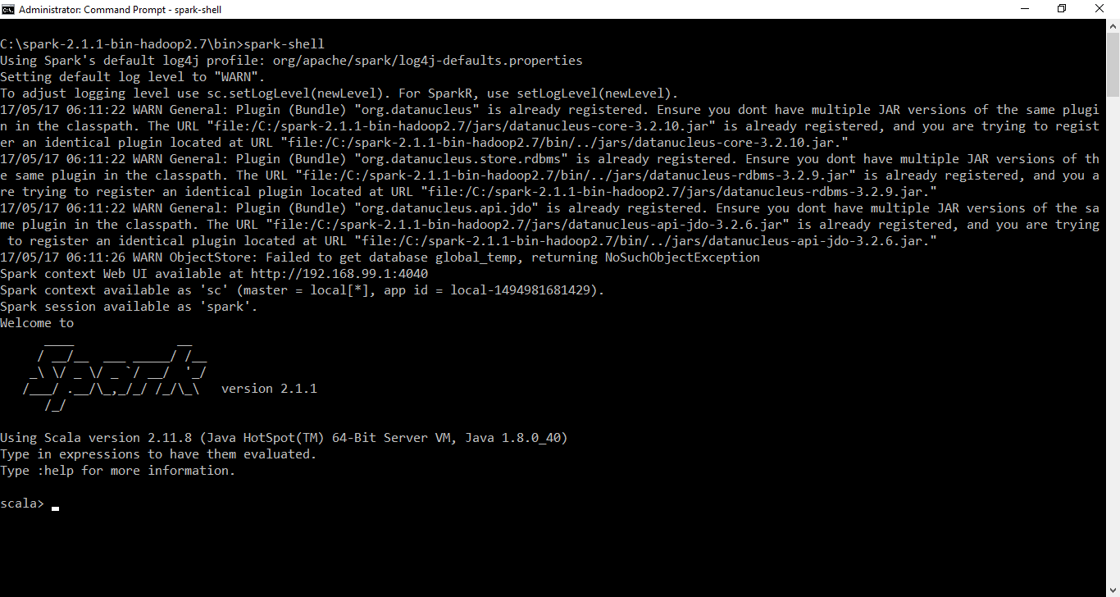

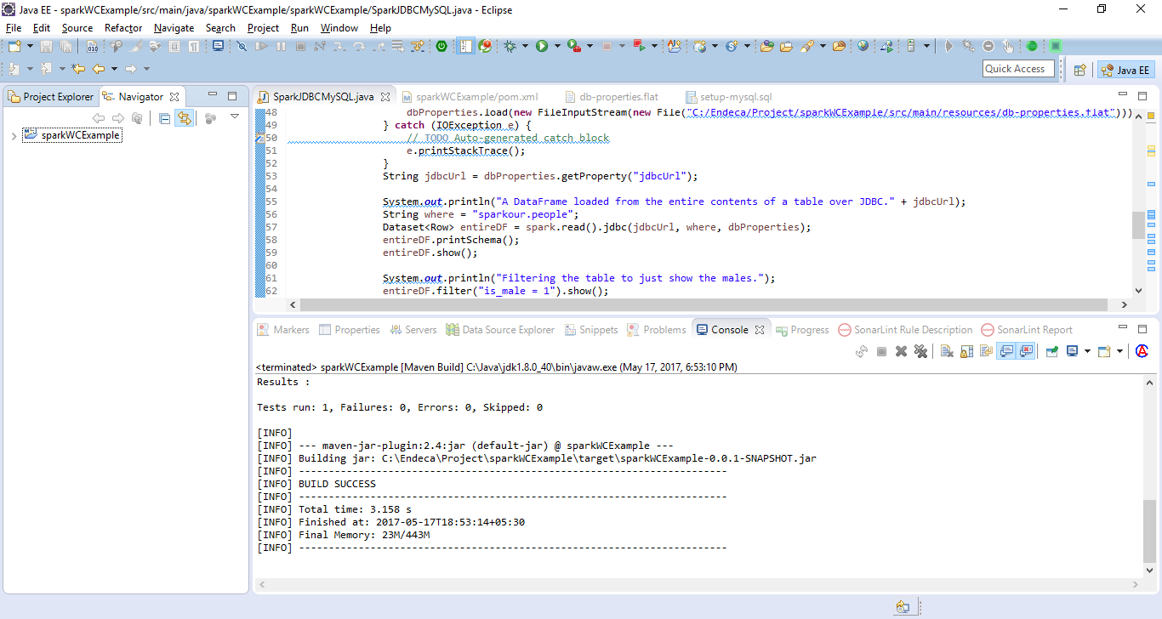

How to create the target folder?

pom.xml - Run As -> Maven build --> set package as goal

How to run Apache Spark?

Without JDBC

spark-submit --class sparkWCExample.sparkWCExample.ReadFromMongoDB --master local[1] /Endeca/Project/sparkWCExample/target/sparkWCExample-0.0.1-SNAPSHOT.jar

or

With JDBC

spark-submit --class sparkWCExample.sparkWCExample.SparkJDBCMySQL --master local[2] --driver-class-path /ATG11/ATG11.1/MySQL/mysql-connector-java-5.1.15-bin.jar /Endeca/Project/sparkWCExample/target/sparkWCExample-0.0.1-SNAPSHOT.jar

With Mongo

spark-submit --class sparkWCExample.sparkWCExample.WriteToMongoDB --master local[2] --jars /Endeca/Project/sparkWCExample/lib/mongo-spark-connector_2.11-1.0.0.jar,/Endeca/Project/sparkWCExample/lib/mongo-java-driver-3.2.2.jar /Endeca/Project/sparkWCExample/target/sparkWCExample-0.0.1-SNAPSHOT.jar

